Security Requests
Security requests are used for requests to add, modify, or remove security (including proxy) in EIS Financials environments (FSPD, FSQA, FSCP, etc.), Oracle/Golden, USAS, Perceptive Content, and Cognos.
To open a security request:
- Access Service Now (http://web3.unt.edu/helpdesk/service). Log in with your EUID and password
- Select “Business Intelligence & Reporting” tile from the Self Service page.
- Select “Financial Systems Support (FSS) and Access Control Executive (ACE) Request” from the “Business Intelligence & Reporting” page).
- A request form will appear; select “Security” from the drop-down menu:
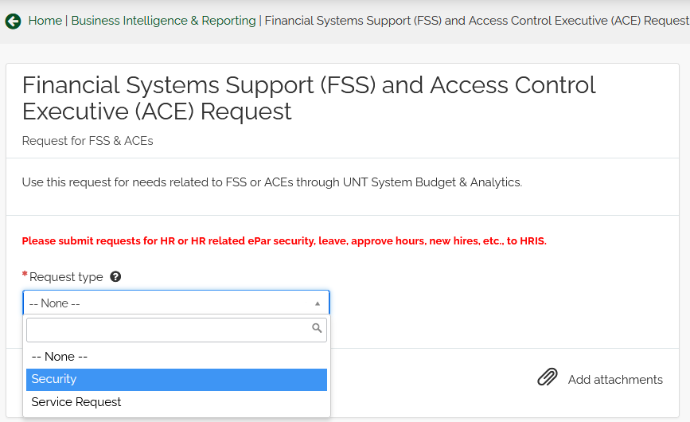

- The Security request form will populate. Complete the form with information requested, including attaching any relevant training certificates, and specify which types of access you are requesting.

The form should be completed for the person for whom the security is requested, rather than that of the requestor when requesting for another person. Entering the EUID where requested will prompt a system search and then populate each of the demographic fields for you.

Options within the form are designated by choosing the drop-down box below the listing, and selecting “Yes”. Items outside of the scope of the request can remain with the default option of “None”.

Note: Additional fields will populate on the form to request any additional information to coordinate with the various types of security selected. Most common roles requested are options within the form; however, if the need is for additional roles, there is a freeform text box at the bottom of the form:

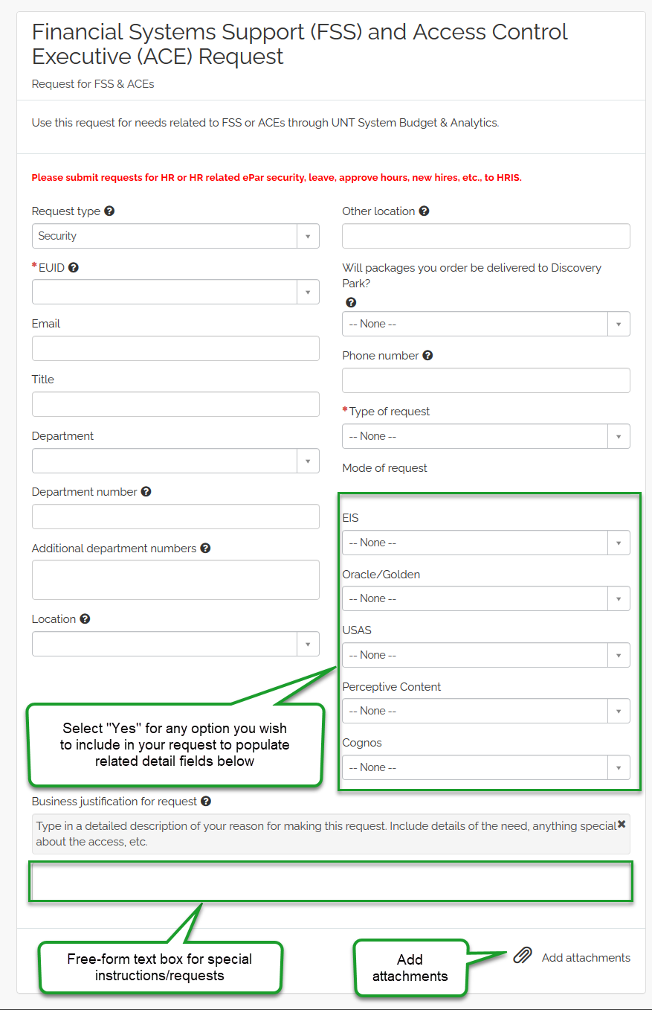
- Once all information is completed on the form and applicable attachments have been added, select “Order Now”
- Indicate for whom the request is, if not for yourself, then select “Checkout”.

